Assessment Parameters
• Complete flow of the application with validation and exception handling -70%
• Comments/best practice, coding standards – 10%
• Execution of the application (Output) – 20%
• ScreenShot should be submitted along with the solution
• The solution(Project) created by the trainee should have the name like AppName_BatchID Ex:ARS_1
• Code with compilation errors will not be considered for evaluation.

Problem Statement:
A Airline Management System provides Airline services to the Customers. It requires an application which allows its Customer to book Filghts. The Flight booking details provided by the Customers are stored into a database and Customer can view the status of the booking along with the Customer ID assigned to him/her. The booking should be accepted when valid seat Number and Seat Type is given as per the list mentioned by Airways Management. (Status of the booking is ‘Not Booked” by default, it will be changed to ”Booked‘”, if it is Booked by Customer as per the valid Seat Numbers and Seat Types available in Flight,and then a Customer ID and will be assigned accordingly.)

SCHEMA.
CREATE TABLE CustomerDetails(CustID NUMBER ,CustName VARCHAR2(25),Email VARCHAR2(30),CustAddress VARCHAR2(25), MobileNo NUMBER(10), SeatType VARCHAR2(15),SeatNo NUMBER(4) references SeatDetail(SeatNO));
CREATE TABLE SeatDetail(SeatNo NUMBER(4) PRIMARY KEY,SeatType VARCHAR2(15), Status VARCHAR2(15)); CREATE SEQUENCE CustomerID_SEQ START WITH 1000

Display menu to the Customer should be as follows
1) Book Seat in a Filght
2) View Booking Status
3) Exit

1. Booking Seat in a Filght [60 Marks]
When the Customer selects this option, it allows the Customer to enter the details as shown in the below sample screen. When all the details are entered should added to the database successfully of above given table, it should print the message “Your Seat has been successfully booked, your Customer ID
is : <cust_id>”.
And immediately Booking status should be changed to Booked for that particular Seat.
Note:
i. Customer ID should be generated using sequence.
ii. Booking status should be made ‘Booked’ if the Seat Number
matches any of the given valid Seat Numbers, according to the
Seat Number list provided in the below table else the status
should be ‘Not Booked’.
iii. The Seat Number is assigned as per the table for valid Seat
Numbers otherwise it is ‘null’
iv. Validation should be taken care for all input fields and Seat Type should be same as given for particular Seat in below table.

Valid Seat Number Seat Type
25 Business_Class
26 Business_Class
27 Business_Class
45 Economy_Class
46 Economy_Class
47 Economy_Class

Note: Seat Number ,Seat Type must be entered from list given in above table only.

Sample Screen
Enter Customer Name: Putin
Enter Email : Putin@yahoo.com
Enter Customer Address: Russia
Enter Mobile No : 123456789
Seat No : 45
Seat Type: Economy_Class.

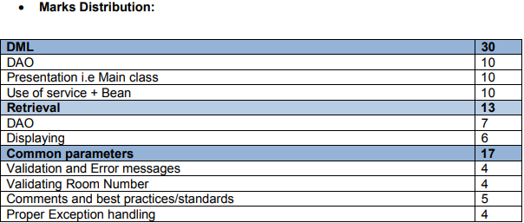

2. View Booking Status
When the Customer selects this option, application should accept the Customer ID from the Customer and display the Booking details as shown in the following sample screen. Validation should be done for Customer ID.

Enter Customer ID : 1000
Display:
Name of the Customer: Putin
Booking Status: Booked
Room No: 45
Room Type: Economy_Class

3. Exit
When Customer selects this option, Customer should be able to quit from application.

1. Each of the DAO operation should be logged into a file using Log4J [5 Marks]
2. Write JUNIT test cases for the methods in the DAO class [5 Marks]

Classes to be created
com.capgemini.Airline.ui
class Client {
public static void main ()
{
// User Interface which display the menu and accept the Input from user
// Create object for service and execute the respective methods}
com.capgemini.Airline.bean
class CustomerBean{ // Bean class for Customer Details with all required properties}
class SeatBooking{//Bean class for Seat Details for customer with all required properties }
Note: Customer Bean can be added as one of the property in Seat Booking bean.
com.capgemini.Airline.service // Service utility classes and Interfaces
Interface IAirlineService {
int addCustomerDetails (CustomerBean bean);
SeatBooking getBookingDetails (int CustomerId);
}
class AirlineService implements IAirlineService {
int addCustomerDetails (CustomerBean bean)){……………}
SeatBooking getBookingDetails (int CustomerId){………………}
}
com.capgemini.Airline.dao // Class to perform Data Accessing logic
Interface ICustomerBookingDAO{
int addCustomerDetails (CustomerBean bean));
SeatBooking getBookingDetails (int CustomerId);
}
Class CustomerBookingDAO implements ICustomerBookingDAO {
int addCustomerDetails (CustomerBean bean)){……………}
SeatBooking getBookingDetails (int CustomerId){………………}
}
Add appropriate user defined exception classes and any other supporting classes required.

